Task-1 Open your own laptop or desktop (or use an online PC hardware simulator if you don't have access to a real system) and identify the GPU model installed. Write down the GPU's brand, model number, and whether it is integrated or dedicated.

Option 1: Dedicated (Discrete) GPU Example
- Brand: NVIDIA

- Model Number: GeForce RTX 4060 (Laptop GPU)

- Type: Dedicated (has its own independent VRAM and is separate from the CPU)

Option 2: Integrated GPU Example
- Brand: Intel

- Model Number: Intel Iris Xe Graphics

- Type: Integrated (built directly into the CPU processor die and shares system RAM)

Task-2 Take a clear photo or screenshot of the cooling system (fan, heatsink, or liquid cooling setup) inside your PC or from a PC hardware simulator. Label the main cooling components and briefly describe their function.

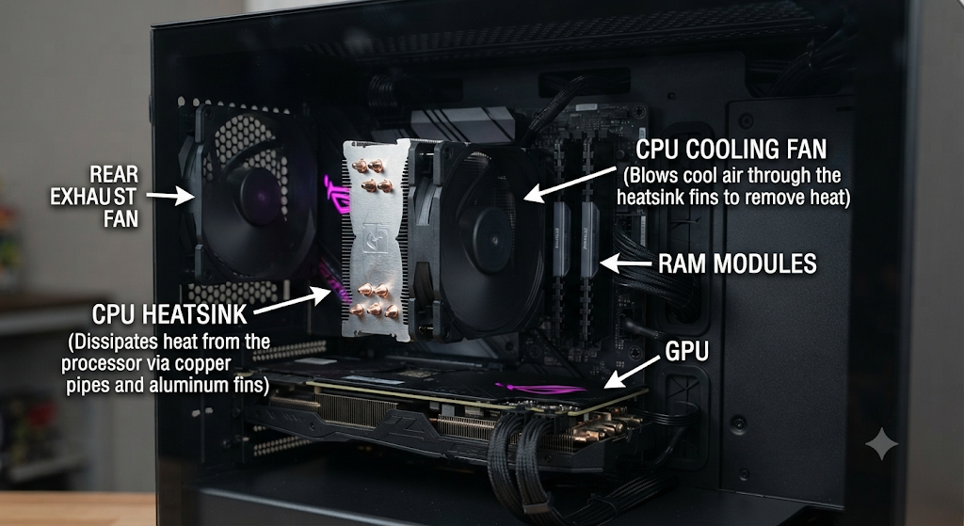

Task-3 Create a comparison table listing at least 3 differences between air cooling and liquid cooling systems for GPUs, including factors like cost, efficiency, and maintenance.

Factor | Air Cooling | Liquid Cooling
Efficiency (Cooling Performance) | Moderate; relies on metal heatsinks and fans. Adequate for standard workloads, but temperatures can rise under sustained heavy loads. | High; utilizes liquid coolant to rapidly transfer heat away from the GPU to a radiator, offering superior thermal management and lower temperatures.
Cost | Economical; usually included with the standard purchase price of the GPU or available at lower aftermarket price points. | Expensive; higher upfront cost for All-In-One (AIO) closed-loop systems or custom loops, along with higher replacement costs.
Maintenance | Low; primarily requires occasional removal of dust buildup from fan blades and heatsink fins. | High; requires monitoring for potential leaks, pump wear, and periodic coolant maintenance or replacement (especially for custom loops).
Noise Level | Can become noticeably loud under heavy loads as fans ramp up speeds to compensate for rising heat. | Generally quieter due to efficient heat dissipation, though pump hum or multiple radiator fans can sometimes produce steady sound.

Task-4 Imagine you are building a gaming PC for streaming IPL matches and playing graphics-heavy games. Choose between air cooling and liquid cooling for your GPU, and justify your choice in 3-4 sentences based on your research.

For a high-performance setup handling graphics-heavy games and simultaneous streaming, liquid cooling is the optimal choice for the GPU. It delivers superior thermal efficiency, rapidly transferring heat away to maintain lower temperatures during prolonged, intensive workloads. This effectively prevents thermal throttling, ensuring smooth frame rates and reliable performance while multi-tasking. While it involves a higher cost and maintenance overhead, the advanced cooling reliability makes it ideal for a demanding gaming and streaming rig.

